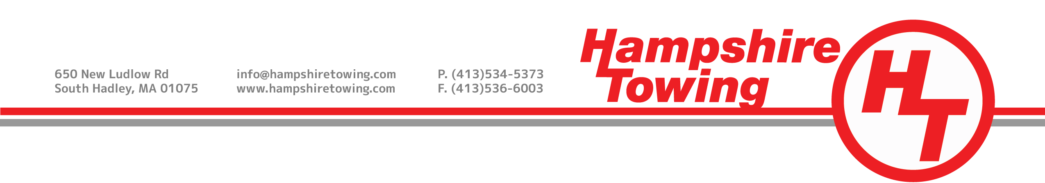
Direction to Pay
Direction to pay the legally entitled certificate carrier or garageman the loading, unloading, and storage of a damaged vehicle.
Date of Loss: _____/_____/_____ Claim Number: _____________________________
Policy Number: __________________________________ Insurance Company: _________________________
Adjuster’s Name: _________________________________ Adjuster’s Phone #: __________________________

My automobile has been placed in storage at:
170 Main Street
Holyoke, MA 01040
650 New Ludlow Rd
South Hadley, MA 01075
31 St. Jacques Ave
Agawam, MA 01001
90 Apremont Way
Westfield, MA 01085
147 Bay Rd
Belchertown, MA 01007

Vehicle Information
Year: _________________________ Make: __________________ Model: _____________________________
Color: ________________________ Plate #: _________________ State: ______________________________
VIN: ______________________________________________________________________________________
I authorize the responsible insurance company to pay the above company directly. I fully understand that, ultimately, I am responsible for any and all costs incurred for this service if the insurance company fails to pay the costs.
Owner’s Signature: ___________________________________________________ Date: _____/_____/_____
Name: ____________________________________________________________________________________
Address: __________________________________________________________________________________
City: _________________________ State:___________________ Zip: ________________________________
Phone Number: ____________________________________________________________________________
Hampshire Towing, Corporate Headquarters: 650 New Ludlow Rd, South Hadley, MA 01075 (413)534-5373
--------------------------------------------------------------------------------------------------------------------------------------------------Invoice/Towbook #: _____________________________________ Employee Name: _____________________

